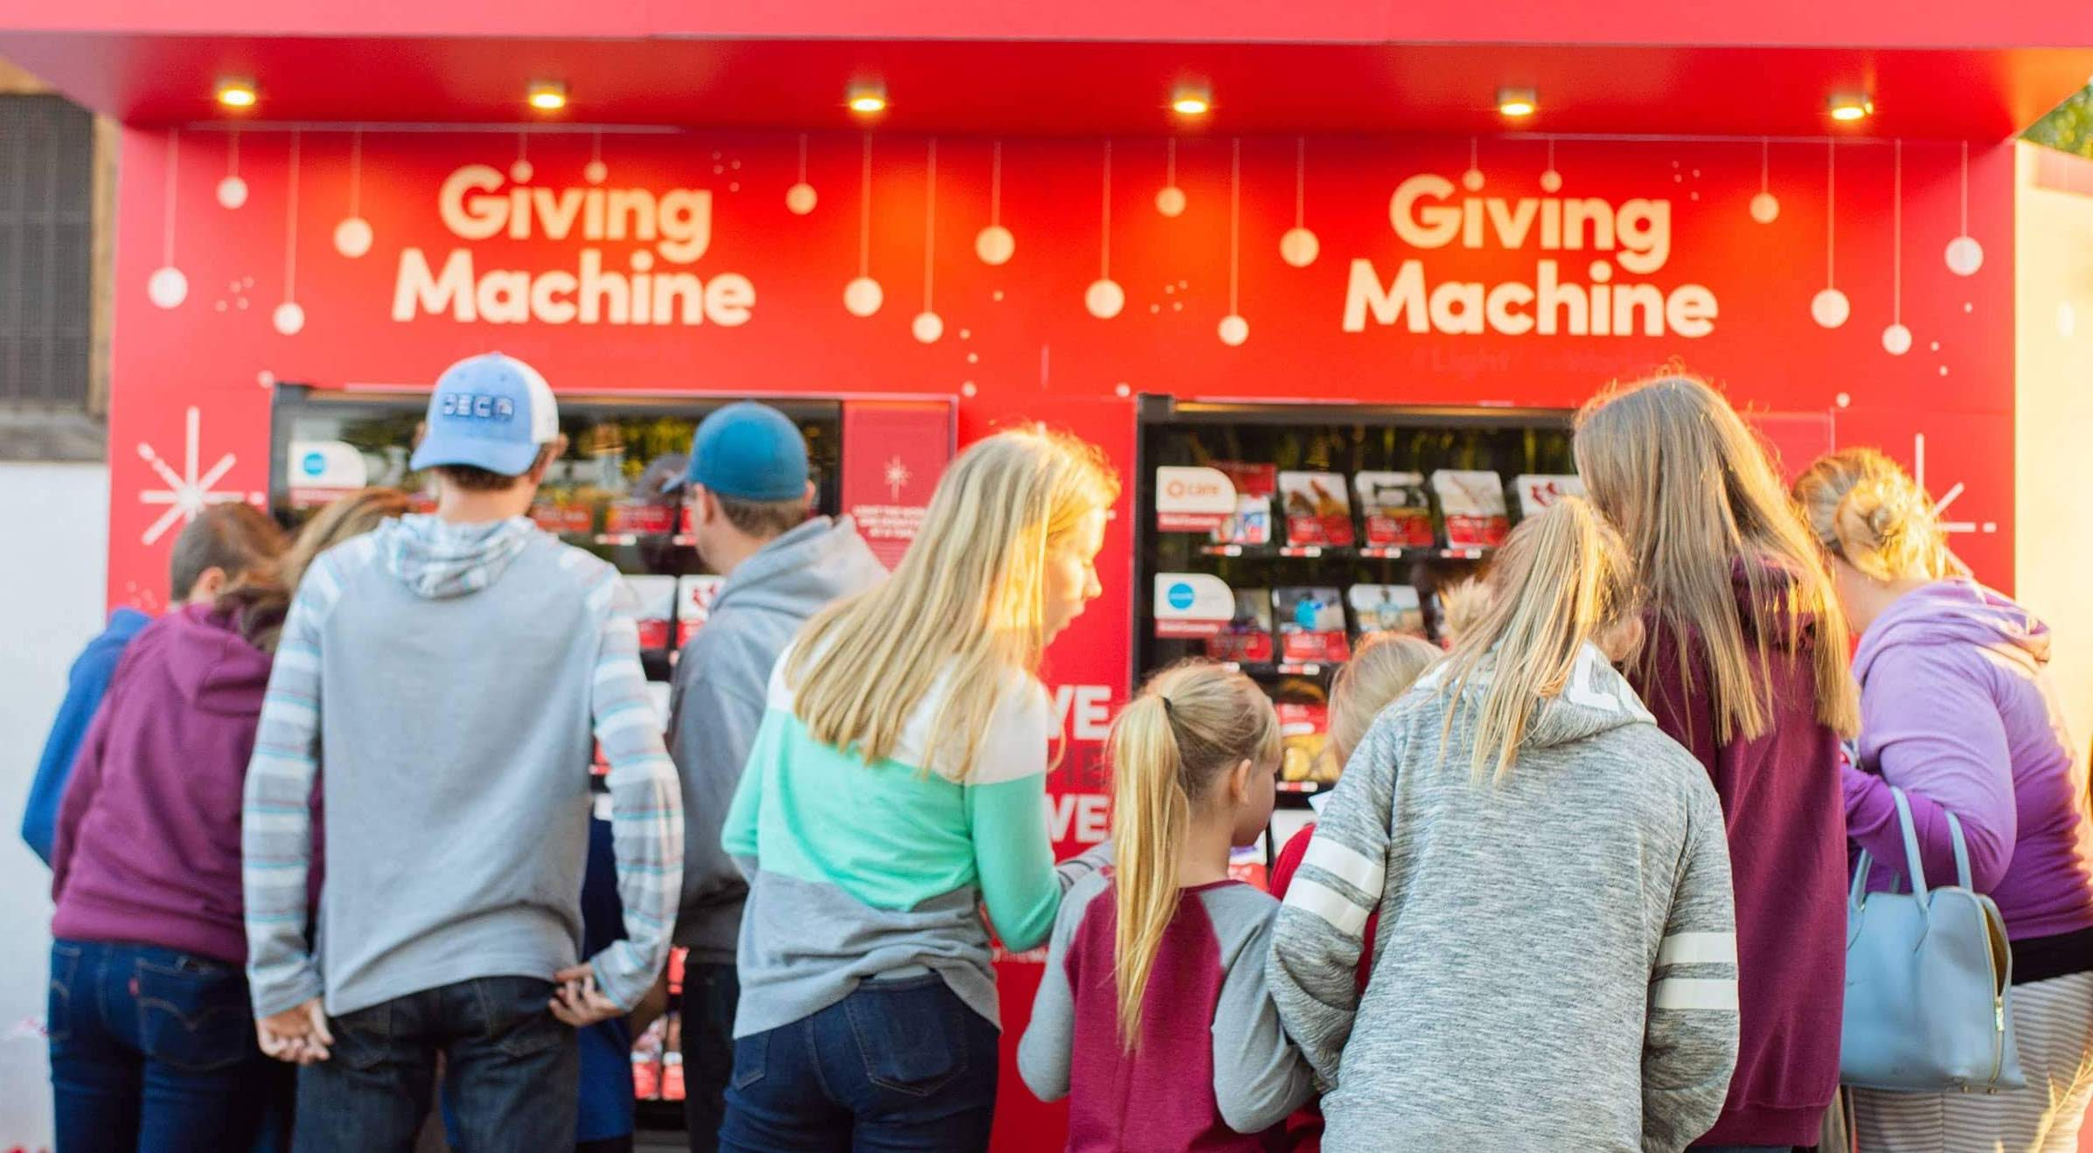

Charity Vending Machines Coming to Denver this Holiday Season

Charitable giving is coming to the streets of Denver this holiday season in an unconventional way: Giving Machines. Sponsored by The Church of Jesus Christ of Latter-day Saints, Giving
Machines use a common and easily understood transactional platform – the vending machine – to allow passersby to make an instant donation to charity. Visitors can actually choose what they want to give from 30 items selected by four local and two global charities.

A bank of three machines will be in place in downtown Denver at Writer Square, 16th Street between Lawrence and Larimer Streets. Giving Machines will open with a Ribbon Cutting and Grand Unwrapping by Denver Mayor Michael B. Hancock at 11 a.m. Tuesday, November 26. From that time they will be open from 9 a.m. to 11 p.m. every day until New Year’s. Volunteers will be available to assist visitors during those hours. Donors simply insert payment and select the item they wish to donate. A card representing the item drops into a bin and the machine records the donation.

Background
The Giving Machines started in 2017 with the simple idea of “how might we give people the opportunity to perform an instant act of service?”

These unique vending machines allow people to purchase books, meals, personal care items, fresh food, clean water and even lambs and piglets for people in need.

In 2017, just four machines in Salt Lake City, UT raised over $550,000 for global and local causes. In 2018, the program expanded to New York, London, Manila, and Gilbert, AZ, and raised $2.3 million more.

2018 Highlights
Giving Machines were in five cities in three countries
$2,309,844 in donations paid for:
- 702,527 meals
- 19,640 chickens
- 4,766 goats
- 3,703 polio vaccines
- 2,312 resuscitation kits for babies
- 1,672 eye exams and glasses
- Many other items ranging from backpacks to mosquito nets to sporting goods
92,190 people participated
18 charities benefited

2019 Locations
Giving Machines will return to Gilbert, AZ; New York City, NY; London, England; Manila, the Philippines and Salt Lake City, UT.

They will be installed for the first time in Denver, CO; Laie, HI; Las Vegas, NV; Orem, UT, and San Jose, CA.

Charities represented in Giving Machines Denver
Charities for Light the World Giving Machines in Denver were submitted for consideration and vetted and selected based on a point system by city leaders, faith partners and The Church of Jesus Christ of Latter-day Saints, with an emphasis on creating opportunities for families to become self-reliant. Four local charities and two international charities are represented.

Black Child Development Institute (BCDI)-Denver: BCDI’s mission is to improve and
advance the quality of life for Black children and families through education and advocacy. They work to implement culturally responsive, trauma sensitive, and evidence-based programs that promote high-quality early care and education, literacy, health, and family engagement.

Items available
- Book with characters of diverse backgrounds
- Starter library
- STEAM kit
- Early Literacy Boot Camp
- Fresh Produce

Catholic Charities of the Archdiocese of Denver: Catholic Charities provides services for
every age and every stage. From young to old, services reach Denver residents through early
childhood education programs and home-based counseling, housing support, and senior services.

Items available:
- Two meals at a women’s shelter
- One blanket
- Ten days of groceries
- Diapers for a month
- Mattress with bedding

Rose Andom Center: The Rose Andom Center is a place for domestic violence victims to find
the safety, support and services needed to rebuild their lives and heal their families. They reach this goal by facilitating better access to services and staff of community organizations and government agencies in a single, safe location.

Items available:
- Bus pass
- Personal care items
- Toys and equipment for playroom
- Well woman visit
- Counseling, legal advocacy, safety planning or health care

Mile High Ministries: Mile High Ministries helps families experiencing homelessness transition
to a stable, healthy living environment. They also provide affordable, mixed-income housing to
help relieve Denver’s affordable housing crisis, legal aid for low-income victims, spiritual
support for any who are interested, and peacemaking strategies for urban living.

Items available:
- Family meal
- Hour of tutoring
- Adult education class
- Backpack and school supplies
- A day and night in a safe shelter

Water for People: There are 2.1 billion people around the world without access to safe water
while 4.5 billion lack adequate sanitation. Women and children spend more than four hours
walking for water each day, and more than 840,000 people die each year from water-related
diseases. Water for People exists to promote the development of high-quality drinking water and sanitation services accessible to all and sustained by strong communities, businesses, and governments.

Items available:
- Box of hand soap
- Tiger worm composting toilet
- Handpump installation
- A year of clean water for one person
- Drill a well

CWS Global: CWS has one goal: building a world where there is enough for all. They address
hunger and poverty with long-term community solutions, aid refugees and immigrants suffering from mass displacement and support victims of disasters through preparation, relief, and recovery, committing to communities before - and long after - disaster hits.

Items available:
- Therapeutic nutrition for a malnourished child
- Three chickens
- One sheep
- One piglet
- One acre of sweet potatoes

All Giving Machines donations will be used for the purchased item or for similar items or
services of greater need as determined by the applicable charitable organization. The Church of Jesus Christ of Latter-day Saints will cover all administrative costs for this campaign and costs associated with its nonprofit partners to ensure that 100 percent of each donation goes to each charity.

#LightTheWorld Initiative

The Giving Machines are part of the annual #LightTheWorld Holiday initiative, organized by
The Church of Jesus Christ of Latter-day Saints. Light the World is an invitation to all to make
the most of the Christmas season by giving as Jesus gave, one person at a time—in our homes, in our communities, and around the globe.

Media contact
For more information, photography and video about Light the World Giving Machines or to
arrange an interview with the charities represented, please contact:
Amy Johnson
Constructive Public Relations
303-570-6400
Amy.Johnson@ConstructivePublicRelations.com

